

MARKET RESEARCH REPORT

“Analysis of Perishable Product Quality and Brand Trust in Zepto”

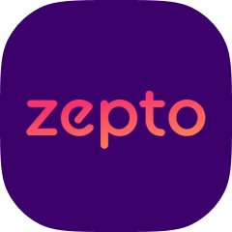

BY: PGP GROUP - 10
Anish Dey - MBA25058
Abhishek Joshi - MBA25051
Shashank Kurnal- MBA25226
Rohit Ghosh- MBA25084
Shreya Yadav - MBA25090
Yoganshi - MBA25096
Naman Srivastava - MBATM25014

Brief Summary

Zepto, a well-known company in the quick-commerce industry, has recently received more negative reviews that focus on the quality of perishable goods, such as fruits, vegetables, and dairy. This study examines whether customer experience variables—spanning from price fairness to perceived reliability—statistically elucidates the variation in "Trust in Freshness."
Using a One-Way ANOVA on a sample of 163 respondents, the study confirms that observed quality, price fairness, and dependability have a significant impact on brand trust. Notably, the "Price Fairness (Q17)" surfaced as the strongest predictor of trust, suggesting that customers heavily equate "value for money" with "freshness".

Introduction and Problem Statement

Background:
The quick-commerce model is based on speed and ease of use. But for things that go bad quickly, "freshness" is what makes them valuable. Recent online reviews indicate a discrepancy between what customers expect and what they receive when ordering perishables on Zepto.

Problem Statement:
Zepto is receiving a noticeable share of negative online reviews related to the quality of perishable items. This project aims to identify whether specific customer-experience factors (trust, perceived quality, value fairness, likelihood to repurchase, switching behavior, etc.) predict or explain these bad reviews.

Research Objective

  - To measure the magnitude of the drop in Brand Trust scores caused by perishable quality failures.
  - To assess customer satisfaction levels regarding the quality of perishable products delivered by Zepto.
  - To analyze the factors influencing customers' perceptions of perishable product quality in quick-commerce services.
  - To evaluate customer response behavior (churn/switching) when they receive poor- quality perishables and understand their impact on overall platform trust.

- Research Methodology
- Research Design: Descriptive & Causal
- Data Source: Primary Data (collected via Google Forms)
- Sample Size: N = 150 respondents (Users of Zepto)
- Scaling: Likert Scale (1–5) and Binary
- Analysis Tool: Microsoft Excel (One-Way ANOVA)
- Dependent Variable (DV): Trust in Freshness (Q13)
- Independent Variables (IV): Satisfaction (Q14), Reorder Influence (Q15), Reliability (Q16), Price Fairness (Q17), Continuation (Q18), Switching Behavior (Q19), Recommendation (Q20).

Data Analysis and Interpretation

To determine if the Independent Variables (IV) significantly affect the Dependent Variable (Trust in Freshness), One-Way ANOVA tests were conducted. A P-value (<) 0.05 indicates statistical significance.

Summary of ANOVA Results
Dependent Variable: Q13(Trust in Freshness)

Variable | Metric | F-Value | P-Value | Interpretation
Q17 | Price Fairness | 53.39 | 1.37E-27 | Highest Significance
Q15 | Reorder Influence | 52.05 | 6.10E-23 | Highly Significant
Q14 | Satisfaction w/ Quality | 35.32 | 1.40E-20 | Highly Significant
Q16 | Reliable Quality Controls | 28.95 | 1.08E-17 | Highly Significant
Q19 | Switching Behavior | 26.04 | 2.81E-16 | Highly Significant
Q20 | Recommendation Likelihood | 4.50 | 0.0018 | Significant
Q18 | Continuation (Loyalty) | 2.44 | 0.049 | Marginally Significant

Detailed Interpretation by Factor

Factor 1: Price Fairness (Q17)
- Result: F = 53.39, P < 0.001
- Analysis: This variable had the highest F-value, showing the strongest relationship with trust.
- Insight: Customers who felt the pricing was unfair correlated with low trust in freshness. This suggests that when customers receive poor-quality produce, they feel cheated on price, resulting in a lowering of their trust.

Factor 2: Satisfaction with Quality (Q14) & Reliability (Q16)
- Result (Q14): F = 35.32, P < 0.001
- Result (Q16): F = 28.95, P < 0.001
- Analysis: Both variables are highly significant.
- Insight: There is a direct causal link between current satisfaction/reliability and the deeper metric of "Trust." A failure in daily quality control (Q16) directly results in degradation of the long-term trust score (Q13).

Factor 3: Switching Behavior (Q19)
- Result: F = 26.04, P < 0.001
- Analysis: Highly significant.
- Insight: This addresses Objective 4. Customers with low trust in freshness are likely to switch to the existing competitors. The variance in trust explains the variance in churn intent.

Factor 4: Continuation/Loyalty (Q18)
- Result: F = 2.44, P = 0.049
- Analysis: This is the weakest link among the factors. Although it is statistically significant (with a p-value < 0.05), the relationship is not strong.
- Insight: This suggests a "Convenience Trap." Customers may continue using Zepto (Q18) despite not trusting its freshness (Q13), as they rely on its speed and convenience. However, this loyalty will become fragile over time.

Findings
Based on the statistical analysis, we get to the following findings that directly mapped to the research objectives:

- Trust is Fragile (Objective 1): When quality is compromised, trust declines significantly. The extremely low P-values for all quality metrics (Q14, Q16) indicate that trust is weak and quickly erodes when quality issues arise.
- Price Fairness is the Anchor (Objective 3): The most significant factor affecting perception is not just the visual quality of the fruit and vegetables, but also Value Fairness. If a customer pays extra for fast delivery and receives subpar avocados, the loss of trust becomes even greater due to the monetary impact.
- Churn is Imminent (Objective 4): There is a clear link between Trust in Freshness (Q13) and Switching Behavior (Q19). Inadequate quality of perishable items strongly predicts customer churn to competitors like Blinkit or Instamart.
- Sad Reviews Proxy (Q20): The likelihood to recommend (Q20) is significant ($P=0.0018$) but not as much as Price or Reliability. This suggests that customers might not immediately leave negative reviews, but they will lose trust and stop buying.

Recommendations

- Set up "Fairness" Refunds: Q17 (Price Fairness) is the most critical factor in building trust, so Zepto needs to have a "No-Questions-Asked" instant refund policy for perishable goods. If the customer thinks the quality was not worth the price, giving them their money back immediately can help maintain their trust score.
- Quality Control at Dark Stores: The significance of Q16 (Reliability) suggests the issue lies in the variability. Zepto needs stricter grading protocols at the dark store level before packing.
- Separate "Fresh" Feedback Loop: Create a specific post-order feedback flow for fruits/veggies. Since Q18 (Continuation) is weak, Zepto cannot rely on general retention metrics to ensure customers are happy with freshness. They are staying for speed, but they are buying perishables elsewhere.

Conclusion

The Null Hypothesis (H0) is rejected for all variables. Customer perceptions of quality, price fairness, and reliability significantly affect their trust in Zepto's ability to deliver fresh items. The data suggests that while customers may seek speed and stay for it (weak correlation in Q18), they are also considering switching (strong correlation in Q19) if the "Value for Money" regarding the freshness of perishable goods is not rectified and justified.

*ANNEXURE*
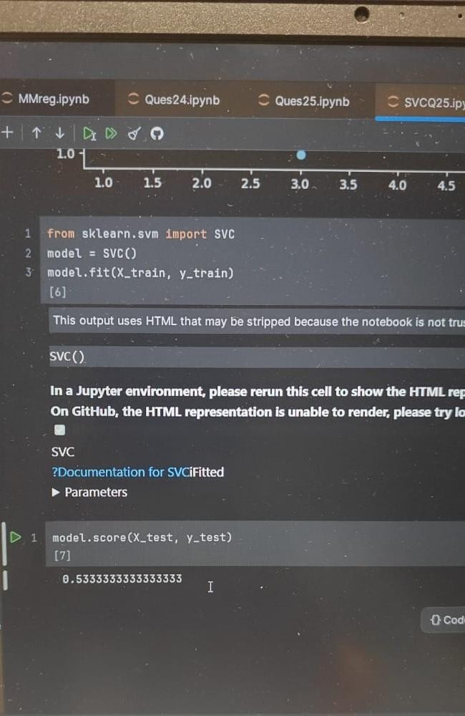
SUPPORT VECTOR CLASSIFICATION
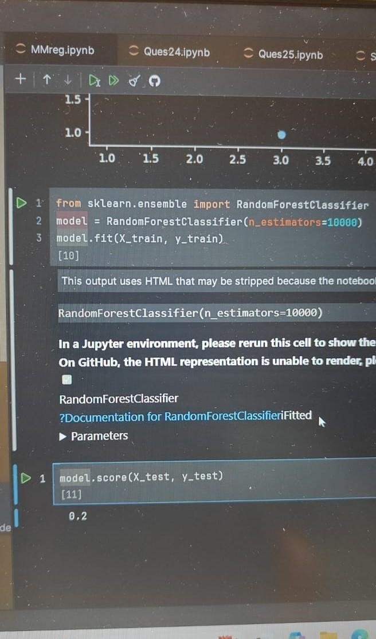
RANDOM FOREST CLASSIFICATION

RANDOM FOREST CLASSIFICATION
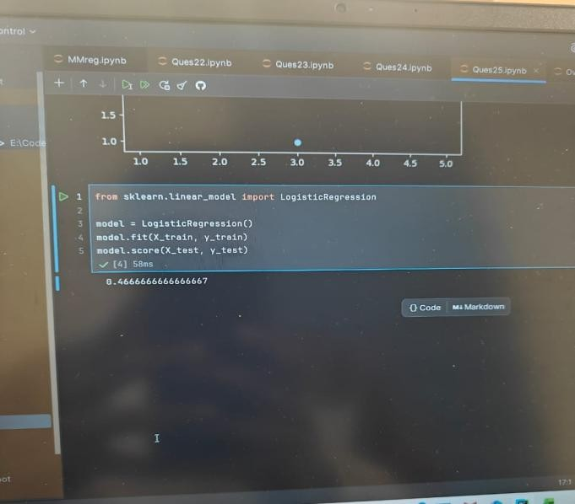
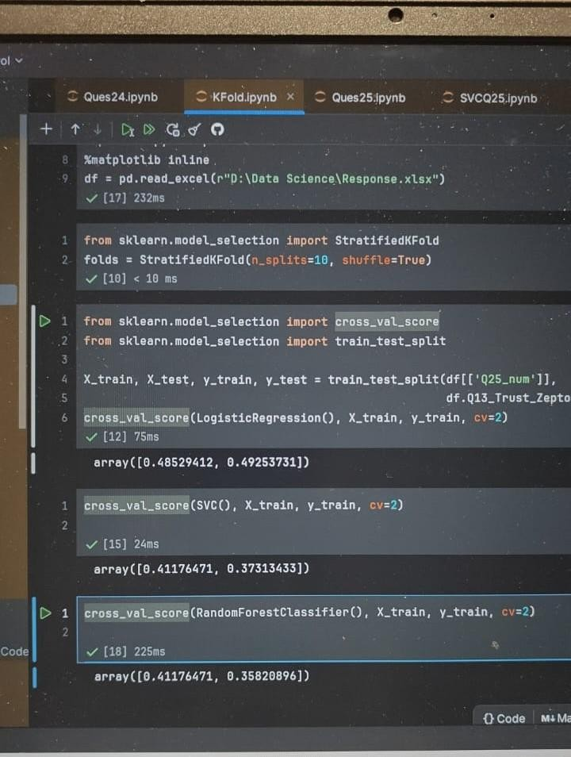
LOGISTIC REGRESSION

KFOLD CROSS VALIDATION

